**Practical No.1**

**Aim**: Write a program in python to read and display an image.

**Softwares Used**: Jupyter Notebook, Opencv

**Environment** : python 3.11.2

**Theory:**

Python is a high-level programming language that is designed to be easy to read and write. Python comes with a large standard library that includes modules for various tasks, such as working with regular expressions, networking, and file I/O. This means that you don't have to write code from scratch for every task, as there's likely a pre-existing module you can use. python is dynamically typed, which means that variables don't need to be declared before they are used, and their types can change at runtime.

OpenCV (Open Source Computer Vision) is an open-source computer vision and machine learning software library. It provides a set of tools and algorithms for image and video processing, machine learning, and computer vision tasks. OpenCV is written in C++, but it also has interfaces for Python, Java, and MATLAB.

**Program Code**:

import cv2

from matplotlib import pyplot as plt print(cv2.__version__)

img = cv2.imread("dolphin.jpg") plt.imshow(cv2.cvtColor(img,cv2.COLOR_BGR2RGB))

plt.title("Dolphin-Original Color Image")

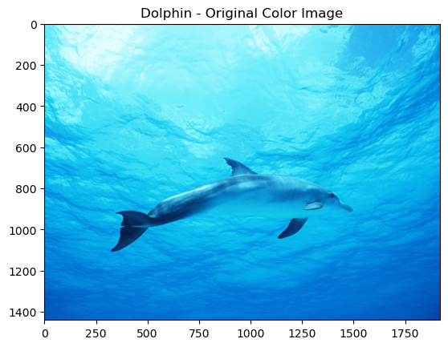**Output**:

4.7.0

Text(0.5, 1.0, 'Dolphin - Original Color Image')

**Conclusion**: In this practical , we successfully study and implement about to read an image and display in RGB scale using python.